Goal: based on the correlogram algorithm of paper Wang and Brown in their paper published in IEEE Transactions on Neural Networks, Vol. 10, pp. 684-697, 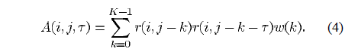
calculate a correlogram for each frequency channel 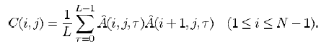
and a summary correlogram 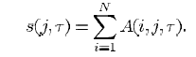
And applied pitch detection.

Execution Setting:

The outputs from hair cell “r” have already been calculated in ar.dat and er.dat with 325*64 data points. “j” is the total 325 frame window which can be ignored here. “i” is the channel with 64 in total. “k” is window width with total 200 width for 20 ms. “w” is the width of correspond window. “t” is the time lag with total 125 time lag for 12.5 ms.

Here we compute autocorrelation correlogram by changing the r(j-k) and r(j-k-t) in the Equation to r(k) and r(k+t) to simplify the calculation.

For pitch detection, we simply find the summary correlogram’s peak point. The time lag of peak point is the period of the pitch. Then we can calculate frequency. The F0 is limited to 80Hz to 222 Hz

Result:
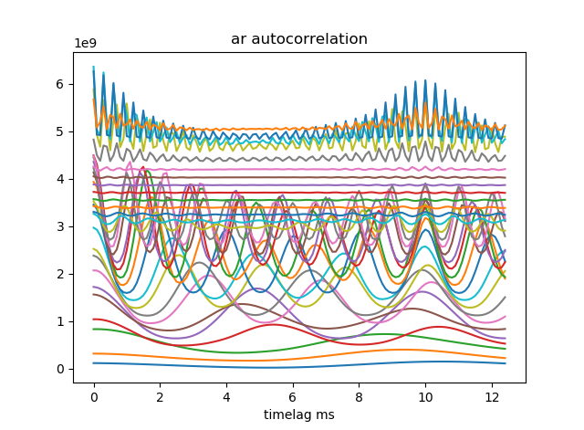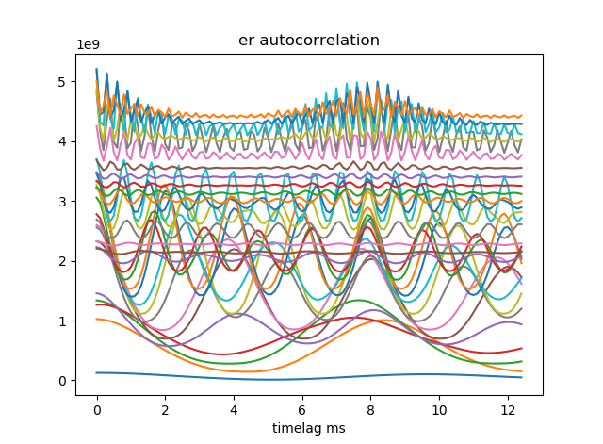

The above is simply a plot of autocorrelation without consider the timestep j and only the autocorrelation function of every second channel is shown. This is similar to the correlogram of the paper.
